COURSERA CAPSTONE

IBM Applied Data Science Capstone

Opening a Mall

Introduction

For many shoppers, visiting shopping malls could be a good way to relax and revel in themselves during weekends and holidays. they will do grocery shopping, dine at restaurants, shop the varied fashion outlets, watch movies and perform more activities. Shopping malls are sort of a one-stop destination for every kind of shoppers. For retailers, the central location and therefore the large crowd at the shopping malls provides a good channel to promote their products and services. Property developers are taking advantage of this trend to create more shopping malls to cater to the demand. As a result, there are many shopping malls within the city of Bangalore and lots of more are being built. Opening shopping malls allows property developers to earn consistent income. Of course, like any business decision, opening a brand new mall requires serious consideration and may be a lot more complicated than it seems. Particularly, the situation of the mall is one in every of the foremost important decisions which will determine whether the mall are going to be successful or a failure.

Business Problem

The objective of this capstone project is to investigate and choose the most effective locations within the city of Bangalore , India to open a brand new store. Using data science methodology and machine learning techniques like clustering, this project aims to supply solutions to answer the business question: within the city of Bangalore, India, if a property developer is looking to open a brand new store, where would you recommend that they open it?
Target Audience of this project
This project is especially useful to property developers and investors looking to open or invest in new shopping malls within the Bangalore city, India .Retail in india is one in every of the pillars of its economy and accounts for about 10 percent of its GDP(https://en.wikipedia.org/wiki/Retailing_in_India).This project is timely because the city is currently plagued by oversupply of shopping malls. The Indian retail sector has metamorphosed significantly over the previous few decades. Rapid urbanization and digitization, rising disposable incomes and lifestyle changes of particularly the middle-class has led to a serious revolution within the retail sector, projected to grow from US$ 672 billion in 2017 to US$ 1.2 trillion in 2021. Evolving rapidly from usual 'kirana shops' to large multi-format stores offering global experience to the e-commerce model that's highly technology-driven, the Indian retail sector has evolved
Data
To solve the matter, we'll need the subsequent data:
• List of neighbourhoods in Bangalore. This defines the scope of this project which is confined to town of Bangalore, the electronic city of the country of India .
• Latitude and longitude coordinates of these neighbourhoods. this can be required so as to plot the map and also to urge the venuedata.
• Venue data, particularly data associated with shopping malls. we are going to use this data to perform clustering on theneighbourhoods.
Sources of knowledge and methods to extract them
This Wikipedia page (https://commons.wikimedia.org/wiki/Category:Suburbs_of_Bangalore) contains an inventory of neighbourhoods in Bangalore, with a complete of 58 neighbourhoods. I will use web scraping techniques to extract the info from the Wikipedia page, with the assistance of Python requests and beautiful-soup packages. Then we are going to get the geographical coordinates of the neighbourhoods using Python Geocoder package which can give us the latitude and longitude coordinates of the neighbourhoods.
After that, we are going to use Foursquare API to urge the venue data for those neighbourhoods. Foursquare has one amongst the most important database of 105+ million places and is employed by over 125,000 developers.
Foursquare API will provide many categories of the venue data, we are particularly inquisitive about the mall category so as to assist us to unravel the business problem hints. this is often a project that may make use of the many data science skills, from web scraping (Wikipedia), working with API (Foursquare), data cleaning, data wrangling, to machine learning (K-means clustering) and map visualization (Folium). within the next section, we'll present the Methodology section where we are going to discuss the steps taken during this project, the info analysis that we did and therefore the machine learning technique that was use

Methodology

Firstly, we need to get the list of neighbourhoods in the city of Bangalore. Fortunately, the list is available in the page (https://commons.wikimedia.org/wiki/Category:Suburbs_of_Bangalore). I will do web scraping using Python requests and beautiful-soup packages to extract the list of neighbourhoods data. However, this is just a list of names. I need to get the geographical coordinates in the form of latitude and longitude in order to be able to use Foursquare API. To do so, we will use the wonderful Geocoder package that will allow us to convert address into geographical coordinates in the form of latitude and longitude. After gathering the data, we will populate the data into a pandas DataFrame and then visualize the neighbourhoods in a map using Folium package. This allows us to perform a sanity check to make sure that the geographical coordinates data returned by Geocoder are correctly plotted in the city of Bangalore.

Next, we will use Foursquare API to get the top 100 venues that are within a radius of 2000 meters. We need to register a Foursquare Developer Account in order to obtain the Foursquare ID and Foursquare secret key. We then make API calls to Foursquare passing in the geographical coordinates of the neighbourhoods in a Python loop. Foursquare will return the venue data in JSON format and we will extract the venue name, venue category, venue latitude and longitude. With the data, we can check how many venues were returned for each neighbourhood and examine how many unique categories can be curated from all the returned venues. Then, we will analyse each neighbourhood by grouping the rows by neighbourhood and taking the mean of the frequency of occurrence of each venue category. By doing so, we are also preparing the data for use in clustering. Since we are analysing the “Shopping Mall” data, we will filter the “Shopping Mall” as venue category for the neighbourhoods.

Lastly, we will perform clustering on the data by using k-means clustering. K-means clustering algorithm identifies k number of centroids, and then allocates every data point to the nearest cluster, while keeping the centroids as small as possible. It is one of the simplest and popular unsupervised machine learning algorithms and is particularly suited to solve the problem for this project. We will cluster the neighbourhoods into “4” clusters based on their frequency of occurrence for “Shopping Mall”. The results will allow us to identify which neighbourhoods have higher concentration of shopping malls while which neighbourhoods have fewer number of shopping malls. Based on the occurrence of shopping malls in different neighbourhoods, it will help us to answer the question as to which neighbourhoods are most suitable to open new shopping malls.

4
Results

The results from the k-means clustering show that we can categorize the neighbourhoods into 4 clusters based on the frequency of occurrence for “Shopping Mall”:

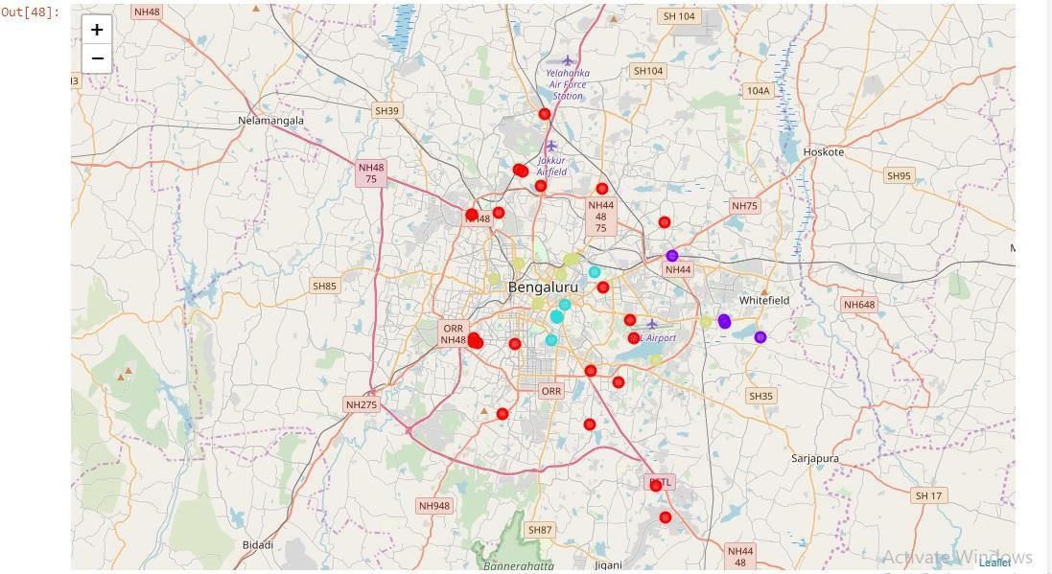

Cluster 0: Neighbourhoods with low number to no existence of shopping malls
Cluster 1: Neighbourhoods with high concentration of shopping malls
Cluster 2:Neighbourhoods with equal concentration shopping malls

Cluster 3:Neighbourhoods with moderate shopping malls

The results of the clustering are visualized in the map below with cluster 0 in red colour, cluster 1 in purple colour, cluster 2 in mint green colour,and cluster 3 whitish yellow.

5
Discussion

As observations noted from the map in the Results section, most of the shopping malls are concentrated in the central area of Bangalore eclectronic city, with the highest number in cluster 2 and moderate number in cluster 2. On the other hand, cluster 0 has very low number to no shopping mall in the neighbourhoods. This represents a great opportunity and high potential areas to open new shopping malls as there is very little to no competition from existing malls. Meanwhile, shopping malls in cluster 3 are likely suffering from intense competition due to oversupply and high concentration of shopping malls. From another perspective, the results also show that the oversupply of shopping malls mostly happened in the central area of the city, with the suburb area still have very few shopping malls. Therefore, this project recommends property developers to capitalize on these findings to open new shopping malls in neighbourhoods in cluster 0 with little to no competition. Property developers with unique selling propositions to stand out from the competition can also open new shopping malls in neighbourhoods in cluster 0 with moderate competition. Lastly, property developers are advised to avoid neighbourhoods in cluster 2 which already have high concentration of shopping malls and suffering from intense competition.

Limitations and Suggestions for Future Research

In this project, we only consider one factor i.e. frequency of occurrence of shopping malls, there are other factors such as population and income of residents that could influence the location decision of a new shopping mall. However, to the best knowledge of this researcher such data are not available to the neighbourhood level required by this project. Future research could devise a methodology to estimate such data to be used in the clustering algorithm to determine the preferred locations to open a new shopping mall.

In addition, this project made use of the free Sandbox Tier Account of Foursquare API that came with limitations as to the number of API calls and results returned. Future research could make use of paid account to bypass these limitations and obtain more results.

6
Conclusion

In this project, we have gone through the process of identifying the business problem, specifying the data required, extracting and preparing the data, performing machine learning by clustering the data into “4” clusters based on their similarities, and lastly providing recommendations to the relevant stakeholders i.e. property developers and investors regarding the best locations to open a new shopping mall. To answer the business question that was raised in the introduction section, the answer proposed by this project is: The neighbourhoods in cluster 2 are the most preferred locations to open a new shopping mall. The findings of this project will help the relevant stakeholders to capitalize on the opportunities on high potential locations while avoiding overcrowded areas in their decisions to open a new shopping mall.

